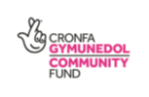
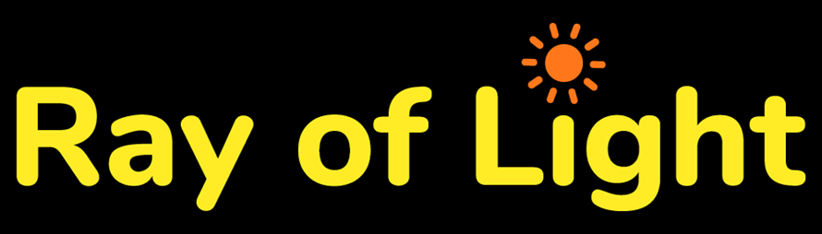

Job Description
Title: Community Project Co-Ordinator
Hours: 15 Hours per Week (3 days Monday to Thursday)
Salary: £25,974 pro rata
Annual Leave 25 days plus bank holidays
PENSION: 3% employer contribution
START DATE: April 2022
LOCATION: Working remotely and at Groups in Cardiff, Rhondda and surrounding areas
This post will also support economically inactive and unemployed people by providing them with volunteering opportunities.
. Responsibilities:
• To recruit and support telephone befriending volunteers
- Receive referrals from beneficiaries with a cancer diagnosis, carer’s and anyone affected by cancer from Social and Health Organisations
- Undertake monitoring and evaluation of projects
- Provide regular reports to the Board of Trustees and steering groups as required.
- Follow all Ray of Light Wales Cancer Support policies and procedures
- To participate in the planning of our Green Social Subscribing Project Recruit, signpost and support beneficiaries into volunteering
- Provide beneficiaries with advice, signposting and information to assist them
- Facilitate Support Groups
- Support programmes and develop new opportunities in Cardiff, RCT and surrounding areas

General
- Promote equality and diversity
- To be responsible for own administration and to assist in the general administration of Ray of Light Wales Cancer Support
- Undertaking training as required
- Be prepared to occasionally work during evenings and at weekends for which flexi/toil time will be granted
- Undertaking other duties that are not detailed in this job description, but which meet ROL’s aims
Person Specification
Job Title: Community Project Co-Ordinator
Essential
- Experience of motivating and organising groups
- Experience of recruiting and supervision of Volunteers
- Excellent communication and organisational skills
- Ability to write reports with good administration skills
- Ability to network and work effectively with organisations and agencies
- An understanding of confidentiality
- Ability to work on own initiative and as a team player
- Commitment to equality and diversity in volunteering
- Knowledge of how barriers impact on the wellbeing of, and opportunities available to people with mental health needs
- IT literate
- The ability to work some weekends and evenings
- An Enhanced DBS check will be required
- Experience of delivering training to groups of people with additional support needs
- Access to transport and ability to travel across Cardiff, Rhondda and surrounding areas
- An understanding of the issues around good practice in working with volunteers
Desirable
- Ability to speak Welsh
- Experience of similar projects
- Proficient in the use of social media
- Good numeracy skills
- Personal experience of volunteering
- Recent employment in the Voluntary Sector

